**Unity 3D Game Engine:**

Unity is a cross-platform game engine developed by Unity Technologies and used to develop video games for PC, consoles, mobile devices and websites. With an emphasis on portability, the engine targets all the major platforms. Unity allows specification of texture compression and resolution settings for each platform the game engine supports, and provides support for

1. Bump mapping,
2. Reflection mapping,
3. Parallax mapping,
4. Screen space ambient occlusion (SSAO),
5. Dynamic shadows using shadow maps,
6. Render-to-texture
7. Full-screen post-processing effects.

Unity is notable for its ability to target games to multiple platforms. Within a project, developers have control over delivery to mobile devices, web browsers, desktops, and consoles. Supported platforms:

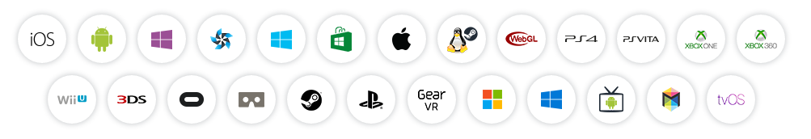

The Unity 3D Engine comes with following features:

**ANIMATION**

1. Retargetable animations
2. Full control of animation weights at runtime
3. Event calling from within the animation playback
4. Sophisticated State Machine hierarchies and transitions
5. Blend shapes for facial animations

**GRAPHICS**

1. Enlighten-powered Real-time Global Illumination
2. Physically-based shading
3. Reflection probes
4. Curve and gradient-driven modular particle system
5. Intuitive UI tools

**OPTIMIZATION**

1. Advanced memory profiling
2. Umbra-powered occlusion culling
3. Asset bundling
4. Level of detail support
5. Build size stripping
6. Multi-threaded job system

**AUDIO**

1. Real-time mixing and mastering
2. Hierarchies of mixers, snapshots and predefined effects

**2D AND 3D PHYSICS**

1. Box2D with a comprehensive range of effectors, joints and colliders
2. NVIDIA® PhysX® 3.3

**SCRIPTING**

1. C# and JavaScript
2. Native Visual Studio integration
3. AI features with advanced automated path finding and Navigation Meshes

We are considering to use this engine for our project so that we can use various platform features provided.

**Links:**

1. https://en.wikipedia.org/wiki/Unity_(game_engine)
2. https://unity3d.com/unity/editor